Soft Computing Assignment -1
K. Sai Pranav
160125742018
1Q. What is a Adaline? Explain the architecture of Adaline?
Ans. Adaline (Adaptive Linear Neuron) is one of the first models of an artificial neural network developed by Bernard Widrow and Ted Hoff. Adaline is a single-layer neural network that uses the linear activation function. The Adaline network is used for solving linear classification and regression problems.
The Adaline network uses the supervised learning approach. The weights in the Adaline network are updated based on the error between the predicted output and the actual output. The Delta rule or the Widrow-Hoff rule is used in the Adaline network. The Delta rule minimizes the Mean Squared Error. The Delta rule is more stable and mathematically efficient compared to the perceptron.
The architecture of Adaline is simple. It is composed of the following components:
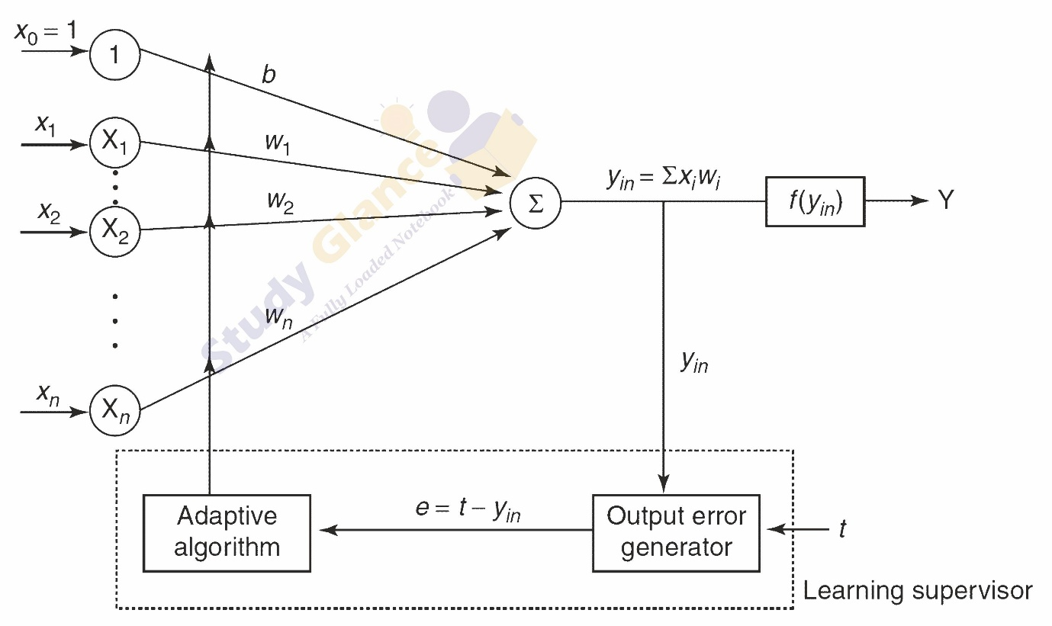
Input Layer:
The inputs to the network are provided in the form of xi, where i represents the number of inputs. The inputs represent the features of the data.
Weights and Bias:
Each input is associated with a weight. A bias is also provided. A constant input of value 1 is also provided for the bias.
Summation Unit:
All inputs with their respective weights and bias are summed up. The net inputs are calculated using the formula:
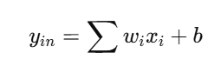
Activation Function:
Adaline uses a linear activation function. There is no threshold in Adaline. Unlike the perceptron, there is no threshold in Adaline.
Output Unit:
The outputs of the network are produced. The outputs may be bipolar in the next versions.
Error Calculation and Learning:
The outputs produced by the network are compared with the target outputs. The error is calculated using the formula:
Error = t – yin
The weight is updated using the delta rule. The formula used is:
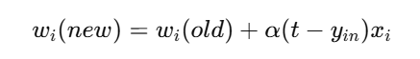
Working of Adaline:
Inputs are applied to the network.
Inputs are multiplied with their respective weights.
Weighted inputs along with bias are summed up.
Linear outputs are produced.
Error is calculated using the formula:
Error = t – yin
Weights are updated using the delta rule.
Key Features:
Adaline is a single-layer neural network.
Adaline uses supervised learning.
Adaline is based on gradient descent optimization.
Adaline uses MSE optimization.
Adaline produces bipolar outputs.
All input neurons are connected to the output neuron.
Bias is always connected.
Adaline is used for linearly separable data.
Adaline cannot be used for non-linear data.
Adaline is a basic neural network model that introduced the concept of error-based learning using the delta rule. Adaline is still used in order to understand more complex neural network models.

2Q. State the steps involved in Adaline learning algorithm.
Ans. The Adaline learning algorithm is used to train the network by adjusting weights in order to minimize the mean squared error (MSE) between the predicted output and the target output. It uses the Delta rule (Widrow-Hoff rule) and follows an iterative learning process based on gradient descent.

Steps of Adaline Learning Algorithm:
Step 1: Initialization
Initialize the weights and bias 𝑏 with small random values (not zero).
Choose a suitable learning rate (𝛼).
Step 2: Repeat Until Stopping Condition is Met
The algorithm continues until the error becomes very small or weights stop changing significantly.
Step 3: Apply Training Samples
For each training example, perform the following steps.
Step 4: Input Assignment
Assign input values to the input units:
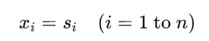
Step 5: Compute Net Input
Calculate the net input to the output neuron:
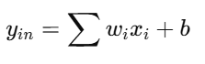
Step 6: Compute Error and Update Weights
Calculate the error:
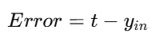
Update weights and bias using Delta rule:
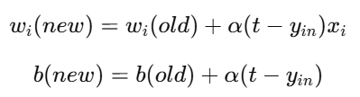
Also compute squared error:
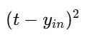
Step 7: Check Stopping Condition
Stop training when:
Error becomes very small, or
There is no significant change in weights, or
Maximum number of epochs is reached
Summary:
- Uses supervised learning
- Based on Delta rule (LMS algorithm)
- Minimizes mean squared error (MSE)
- Updates weights iteratively for each training sample
- Stops when convergence is achieved
The Adaline learning algorithm is a simple yet effective method that continuously updates weights using error feedback, allowing the network to learn optimal parameters for accurate prediction.

3Q. Design OR gate using Adaline Network? Trace it for two inputs
Ans. The OR gate can be implemented using an Adaline network because it is a linearly separable problem. In Adaline, we typically use bipolar representation, where:
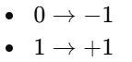
| (x_1) | (x_2) | Target (t) |
| ----- | ----- | ---------- |
| 1 | 1 | 1 |
| 1 | -1 | 1 |
| -1 | 1 | 1 |
| -1 | -1 | -1 |
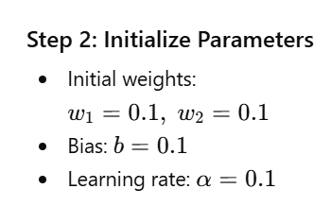
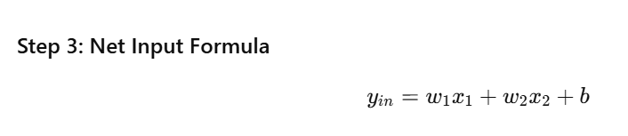
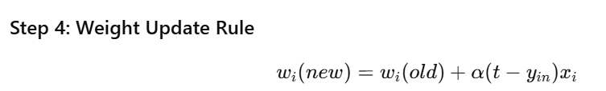
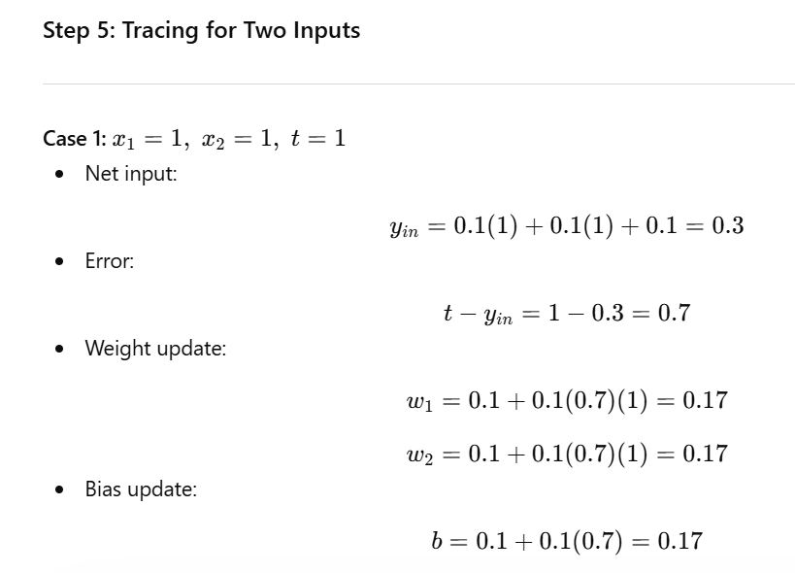
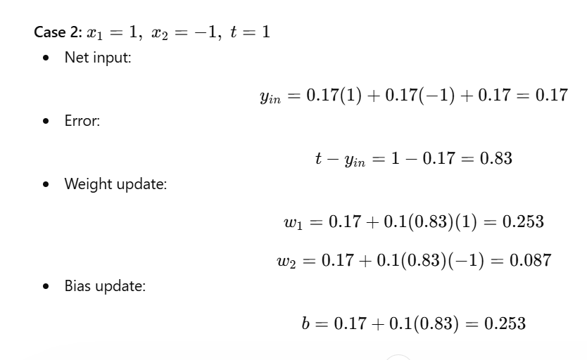4Q. Implement the above design using Python and test it.
Ans. Python code-
import numpy as np

# Adaline Training Function
def adaline(X, T, lr=0.1, epochs=15):
# Initialize weights and bias
w = np.random.rand(X.shape[1])
b = np.random.rand(1)

print("Initial Weights:", w)
print("Initial Bias:", b)

# Training
for epoch in range(epochs):
total_error = 0
for i in range(len(X)):
# Net input
y_in = np.dot(w, X[i]) + b

# Error
error = T[i] - y_in

# Update weights and bias
w = w + lr * error * X[i]
b = b + lr * error

# Sum of squared error
total_error += error**2

print(f"Epoch {epoch+1}, Error: {total_error}")

return w, b

# OR Gate Data (Bipolar)
X = np.array([
[1, 1],
[1, -1],
[-1, 1],
[-1, -1]
])

T = np.array([1, 1, 1, -1])

# Training the model
w, b = adaline(X, T, lr=0.1, epochs=15)

print("\nFinal Weights:", w)
print("Final Bias:", b)

# Prediction Function
def predict(X, w, b):
outputs = []
for i in range(len(X)):
y_in = np.dot(w, X[i]) + b
y = 1 if y_in >= 0 else -1 # Activation
outputs.append(y)
return outputs

# Testing the model
output = predict(X, w, b)

print("\nPredicted Outputs:", output)
print("Expected Outputs :", T)
Output-
Initial Weights: [0.66663306 0.01766857]
Initial Bias: [0.02536084]
Epoch 1, Error: [3.06455762]
Epoch 2, Error: [1.97691729]
Epoch 3, Error: [1.57868122]
Epoch 4, Error: [1.43834126]
Epoch 5, Error: [1.39237885]
Epoch 6, Error: [1.3796421]
Epoch 7, Error: [1.3777636]
Epoch 8, Error: [1.37887634]
Epoch 9, Error: [1.38041461]
Epoch 10, Error: [1.38167557]
Epoch 11, Error: [1.38256278]
Epoch 12, Error: [1.38314504]
Epoch 13, Error: [1.38351297]
Epoch 14, Error: [1.38374026]
Epoch 15, Error: [1.38387859]

Final Weights: [0.52949878 0.55856863]
Final Bias: [0.49948535]

Predicted Outputs: [1, 1, 1, -1]
Expected Outputs : [ 1 1 1 -1]

5Q. What is a Medaline? Explain the architecture of Medaline?
Ans. Madaline (Multiple Adaptive Linear Neuron) is an extension of the Adaline network developed by Bernard Widrow and Ted Hoff. While Adaline consists of a single neuron, Madaline is a multi-layer feedforward neural network that uses multiple Adaline units to solve more complex problems.
Madaline is capable of handling non-linearly separable problems (such as XOR), which cannot be solved using a single-layer Adaline network. It follows a supervised learning approach, where weights are adjusted to minimize classification error.
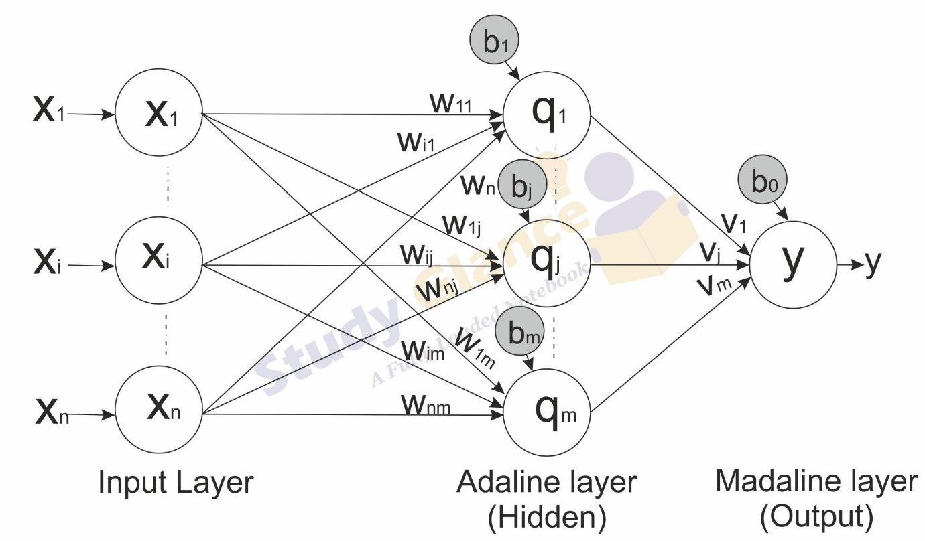
1. Input Layer:
Receives input signals No computation is performed; it simply forwards inputs to the next layer.
2. Hidden Layer (Adaline Units):
Contains multiple Adaline neurons.
Each neuron computes a weighted sum of inputs and adds a bias.
Applies a bipolar activation function (+1 or −1).
These neurons learn different features of the input data.
3. Output Layer:
Combines outputs from hidden layer neurons.
Produces the final output using a fixed logic function (e.g., majority vote or AND/OR rule).
Typically has fixed weights (not adjusted during training).
Working of Madaline:
Inputs are given to multiple Adaline units in the hidden layer.
Each unit processes inputs independently.
Their outputs are combined in the output layer.
The final output is generated based on a decision rule.
Learning is done by adjusting weights between input and hidden layer.
Points:
- Multi-layer neural network (Input → Hidden → Output)
- Uses multiple Adaline units
- Can solve non-linear problems (e.g., XOR)
- Uses supervised learning
- Hidden layer weights are adjustable, output layer weights are usually fixed
- Often uses majority voting mechanism for output decision

6Q. State the steps involved in Medaline learning algorithm.
Ans. 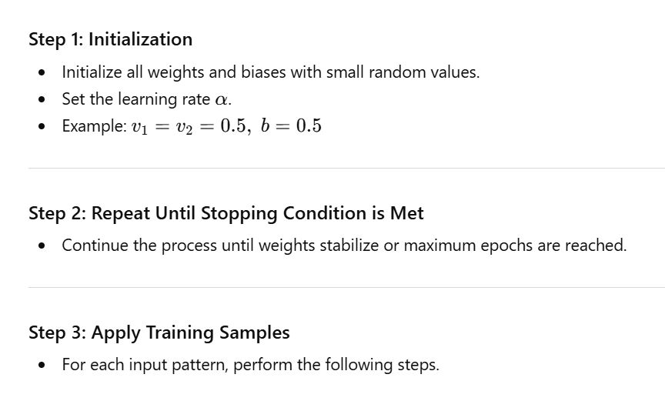
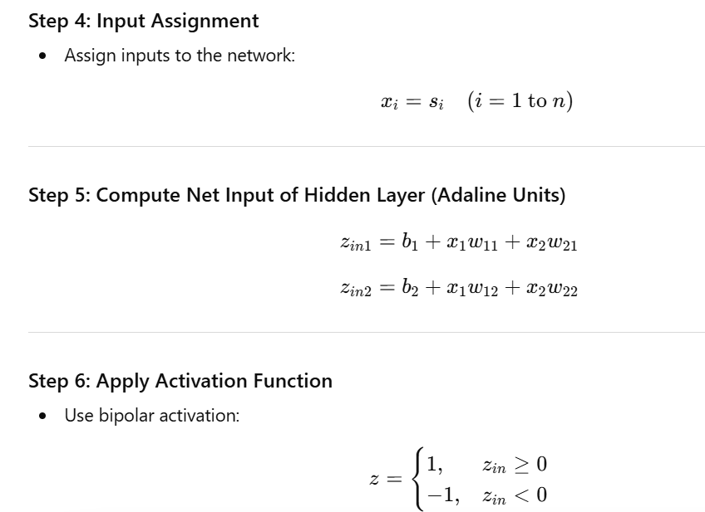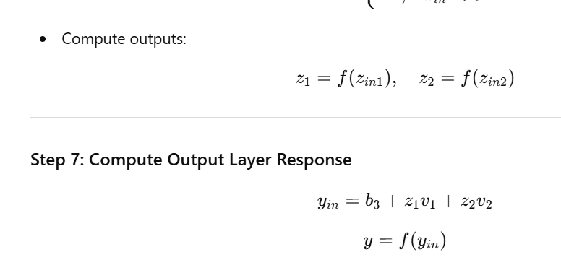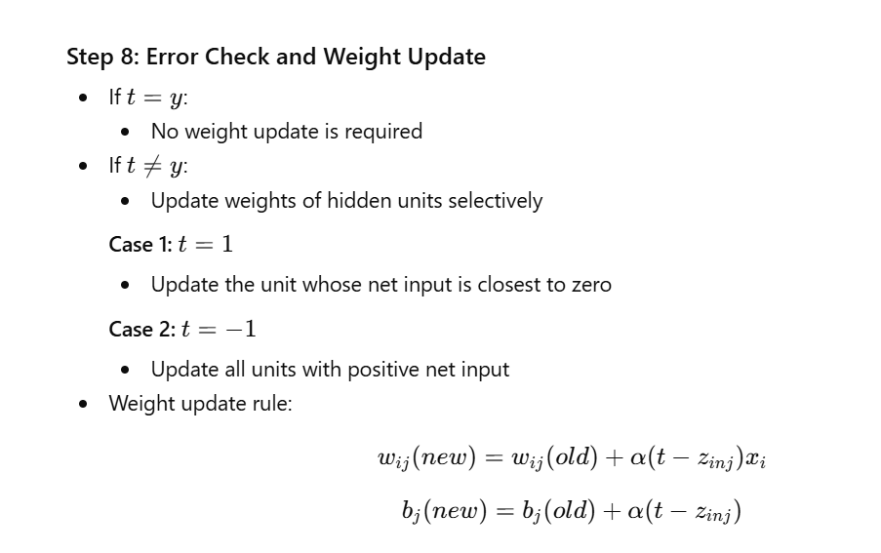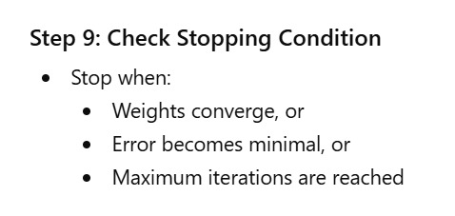
7Q. Using the Madaline network, design XOR function with bipolar inputs and targets. Assume the required parameter for the training of the network. Trace it with two inputs.
Ans. The XOR function is a non-linearly separable problem, so it cannot be implemented using a single Adaline. Hence, we use a Madaline network with multiple Adaline units in the hidden layer to solve this problem.
| (x_1) | (x_2) | Target (t) |
| ----- | ----- | ---------- |
| 1 | 1 | -1 |
| 1 | -1 | 1 |
| -1 | 1 | 1 |
| -1 | -1 | -1 |
v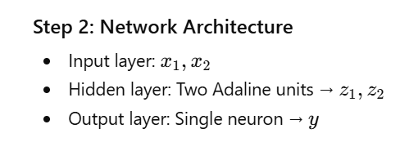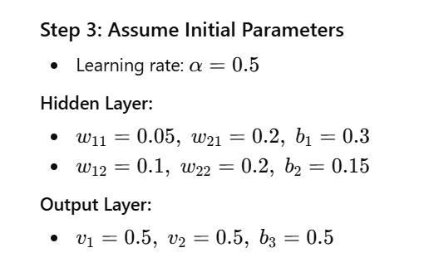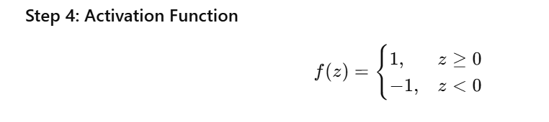
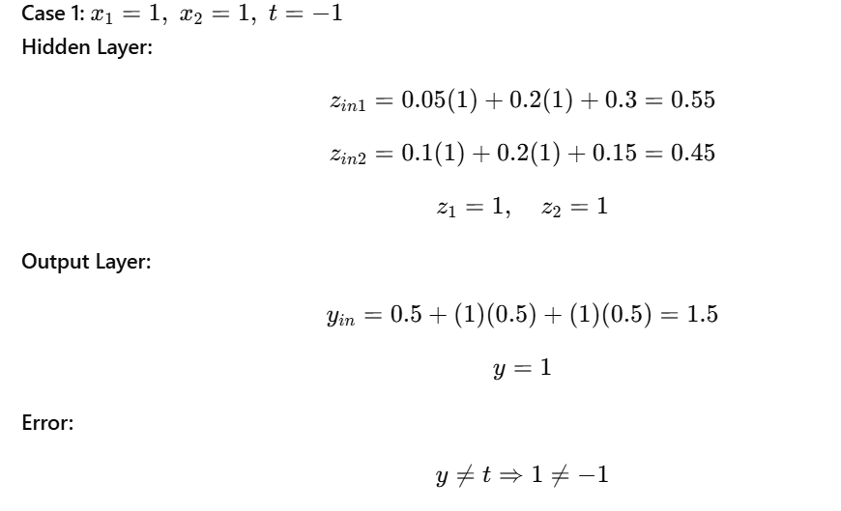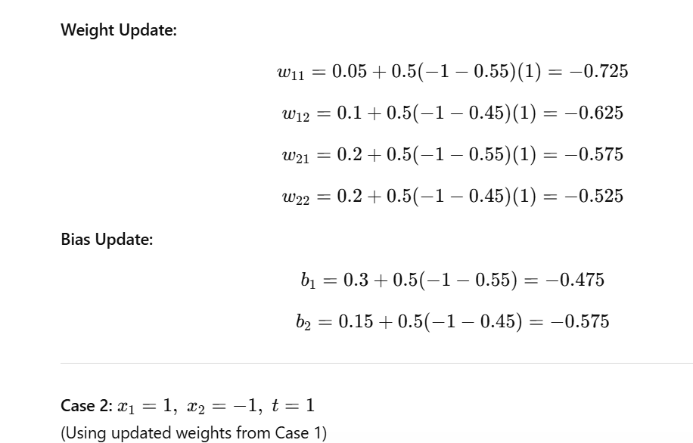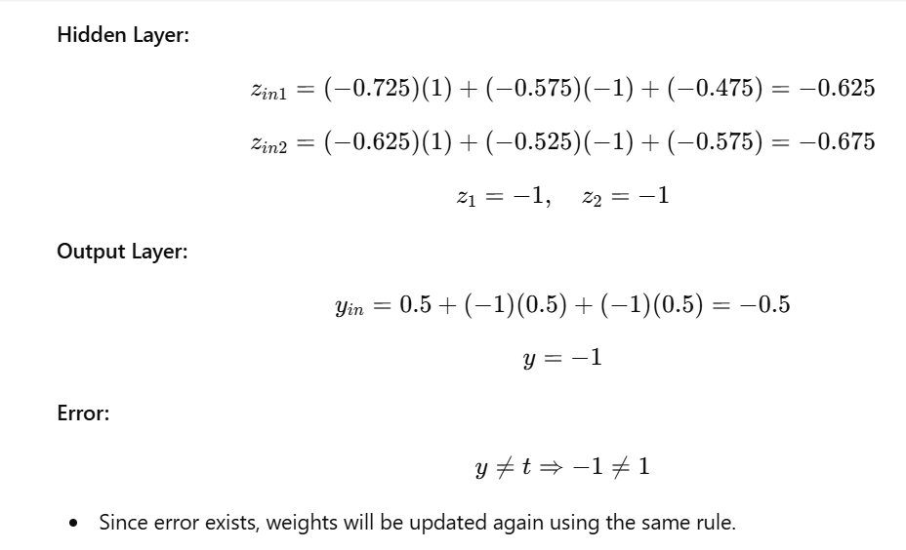

8Q. Implement the above design using Python and test it.
Ans. Python code –
import numpy as np

# Activation function (bipolar)
def activation(z):
return 1 if z >= 0 else -1

# Madaline Network for XOR
def madaline_xor(X, T, lr=0.5, epochs=10):
# Initialize weights (as assumed)
w11, w21, b1 = 0.05, 0.2, 0.3
w12, w22, b2 = 0.1, 0.2, 0.15
v1, v2, b3 = 0.5, 0.5, 0.5

for epoch in range(epochs):
print(f"\nEpoch {epoch+1}")
for i in range(len(X)):
x1, x2 = X[i]
t = T[i]

# Hidden layer
zin1 = b1 + x1*w11 + x2*w21
zin2 = b2 + x1*w12 + x2*w22

z1 = activation(zin1)
z2 = activation(zin2)

# Output layer
yin = b3 + z1*v1 + z2*v2
y = activation(yin)

print(f"Input: {X[i]}, Output: {y}, Target: {t}")

# Weight update if error exists
if y != t:
# Update hidden layer weights
w11 += lr * (t - zin1) * x1
w21 += lr * (t - zin1) * x2
w12 += lr * (t - zin2) * x1
w22 += lr * (t - zin2) * x2

# Update biases
b1 += lr * (t - zin1)
b2 += lr * (t - zin2)

return (w11, w21, w12, w22, b1, b2, v1, v2, b3)

# XOR Data (Bipolar)
X = np.array([
[1, 1],
[1, -1],
[-1, 1],
[-1, -1]
])

T = np.array([-1, 1, 1, -1])

# Train the model
weights = madaline_xor(X, T, lr=0.5, epochs=5)

# Testing Phase
print("\nTesting the Madaline Network:")
for i in range(len(X)):
x1, x2 = X[i]

zin1 = weights[4] + x1*weights[0] + x2*weights[1]
zin2 = weights[5] + x1*weights[2] + x2*weights[3]

z1 = activation(zin1)
z2 = activation(zin2)

yin = weights[8] + z1*weights[6] + z2*weights[7]
y = activation(yin)

print(f"Input: {X[i]} → Output: {y}, Expected: {T[i]}")
Output-
Epoch 1
Input: [1 1], Output: 1, Target: -1
Input: [ 1 -1], Output: -1, Target: 1
Input: [-1 1], Output: -1, Target: 1
Input: [-1 -1], Output: 1, Target: -1

Epoch 2
Input: [1 1], Output: 1, Target: -1
Input: [ 1 -1], Output: -1, Target: 1
Input: [-1 1], Output: -1, Target: 1
Input: [-1 -1], Output: 1, Target: -1

Epoch 3
Input: [1 1], Output: 1, Target: -1
Input: [ 1 -1], Output: -1, Target: 1
Input: [-1 1], Output: -1, Target: 1
Input: [-1 -1], Output: 1, Target: -1

Epoch 4
Input: [1 1], Output: 1, Target: -1
Input: [ 1 -1], Output: -1, Target: 1
Input: [-1 1], Output: -1, Target: 1
Input: [-1 -1], Output: 1, Target: -1

Epoch 5
Input: [1 1], Output: 1, Target: -1
Input: [ 1 -1], Output: -1, Target: 1
Input: [-1 1], Output: -1, Target: 1
Input: [-1 -1], Output: 1, Target: -1

Testing the Madaline Network:
Input: [1 1] → Output: 1, Expected: -1
Input: [ 1 -1] → Output: -1, Expected: 1
Input: [-1 1] → Output: 1, Expected: 1
Input: [-1 -1] → Output: -1, Expected: -1

9Q. What is a backpropagation in neural network? Explain the working of backpropagation algorithm.
Ans. Backpropagation is a supervised learning algorithm used in multi-layer neural networks to train the model by adjusting weights based on error. It works by propagating the error backwards from the output layer to the input layer and updating the weights using gradient descent.
In simple terms, backpropagation helps the network learn by telling it how much it was wrong and how to correct itself.
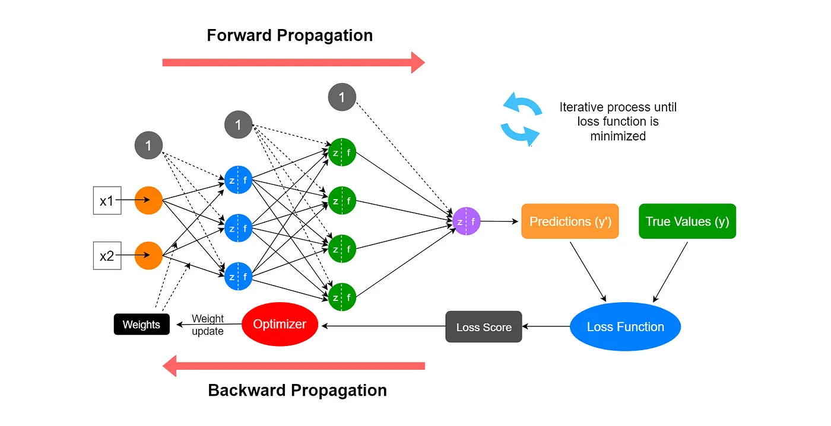
Step 1: Forward Pass
The input data is fed into the network.
The input data is passed through the hidden layers with the help of weights and activation functions.
The network produces an output.

Step 2: Calculate Error
The network's output is compared with the target output.
The error is calculated with the help of loss function, which is known as Mean Squared Error.
Error = Target - Output

Step 3: Backward Pass (Error Propagation)
The error is passed backwards through the network.
The partial derivatives of the error with respect to the weights are calculated.

Step 4: Compute Gradients
The gradients represent the amount of error in each weight.
The gradients are used to calculate how much error is present in each weight.

Step 5: Update Weights
The weights are updated with the help of gradient descent.
w = w + α * gradient
This minimizes the error for future predictions.

Step 6: Repeat the Process
The above process is repeated for multiple epochs until:
The error is very low, or
The desired accuracy is achieved.

Key Points:
It is used in multi-layer neural networks.
It is based on gradient descent optimization.
It uses the chain rule of differentiation.
It works in two phases.
It minimizes error.

10Q. Design and implement a backpropagation network for XOR function.
Ans. The XOR function is a non-linearly separable problem, so it cannot be solved using a single-layer network. Therefore, we use a multi-layer neural network trained using the backpropagation algorithm.
Step 1: XOR Training Data (Bipolar Form)
| (x_1) | (x_2) | Target (t) |
| ----- | ----- | ---------- |
| -1 | -1 | -1 |
| -1 | 1 | 1 |
| 1 | -1 | 1 |
| 1 | 1 | -1 |
Step 2: Network Architecture
Input layer: 2 neurons
Hidden layer: 2 neurons
Output layer: 1 neuron
Activation function: tanh (bipolar output)
Step 3: Working
Inputs are passed through the network (forward pass).
Output is computed and compared with target.
Error is calculated.
Backpropagation adjusts weights using gradients.
Process repeats until error is minimized.
Python Code –
import numpy as np

# Activation functions
def tanh(x):
return np.tanh(x)

def tanh_derivative(x):
return 1 - np.tanh(x) ** 2

# XOR Data (Bipolar)
X = np.array([
[-1, -1],
[-1, 1],
[1, -1],
[1, 1]
], dtype=float)

T = np.array([-1, 1, 1, -1], dtype=float)

# Initialize weights
np.random.seed(42)
w_hidden = np.random.uniform(-0.5, 0.5, (2, 2))
b_hidden = np.zeros(2)

w_output = np.random.uniform(-0.5, 0.5, 2)
b_output = 0.0

# Training parameters
lr = 0.5
epochs = 5000

# Training using backpropagation
for epoch in range(1, epochs + 1):
total_error = 0
for x, t in zip(X, T):

# Forward pass
hidden_in = np.dot(x, w_hidden) + b_hidden
hidden_out = tanh(hidden_in)

y_in = np.dot(hidden_out, w_output) + b_output
y_out = tanh(y_in)

# Error
error = t - y_out
total_error += error ** 2

# Backward pass
delta_out = error * tanh_derivative(y_in)

# Update output weights
w_output += lr * delta_out * hidden_out
b_output += lr * delta_out

# Update hidden weights
for i in range(w_hidden.shape[1]):
delta_hidden = delta_out * w_output[i] * tanh_derivative(hidden_in[i])
w_hidden[:, i] += lr * delta_hidden * x
b_hidden[i] += lr * delta_hidden

# Print error every 500 epochs
if epoch % 500 == 0:
mse = total_error / len(X)
print(f"Epoch {epoch} | MSE: {mse:.6f}")

# Testing
print("\nTesting XOR:")
for x, t in zip(X, T):
hidden_out = tanh(np.dot(x, w_hidden) + b_hidden)
y_out = tanh(np.dot(hidden_out, w_output) + b_output)
y = 1 if y_out >= 0 else -1
print(f"Input: {x} → Output: {y}, Expected: {int(t)}")
output-
Epoch 500 | MSE: 0.000437
Epoch 1000 | MSE: 0.000209
Epoch 1500 | MSE: 0.000137
Epoch 2000 | MSE: 0.000102
Epoch 2500 | MSE: 0.000081
Epoch 3000 | MSE: 0.000067
Epoch 3500 | MSE: 0.000057
Epoch 4000 | MSE: 0.000050
Epoch 4500 | MSE: 0.000044
Epoch 5000 | MSE: 0.000040

Testing XOR:
Input: [-1. -1.] → Output: -1, Expected: -1
Input: [-1. 1.] → Output: 1, Expected: 1
Input: [ 1. -1.] → Output: 1, Expected: 1
Input: [1. 1.] → Output: -1, Expected: -1

